What do they do? (1)
Look at the pictures and identify the jobs. Complete the names of the jobs (a-m) and match them with the pictures (1-13). To guess the jobs you have a clue next to the written word.


2
1
3
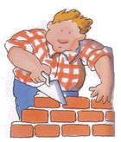

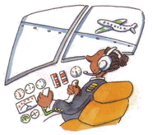

4



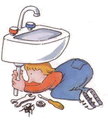
5


___ a) _RT_ _T
___ b) P_ _ OT
___ c) _U_ _E
___ d) A_T_ _
___ e) _ _ST_AN
___ f) _U_L_ER
___ g) D_N_ _R
___ h) W_ _T_E_S
___ i) _EC_ _T_RY
___ j) P_ _MB_ _
___ k) _O_ _OR
___ l) C_E_
___ m) _LE_ _RI_ _AN




7

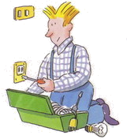

6
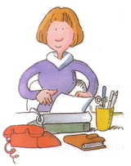










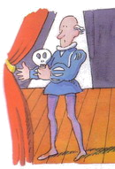


8
9




12
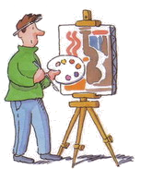

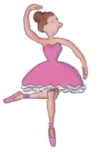
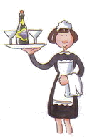
10

11
13

KEY
12 a) ARTIST
3 b) PILOT
9 c) NURSE
8 d) ACTOR
1 e) POSTMAN
2 f) BUILDER
13 g) DANCER
11 h) WAITRESS
6 i) SECRETARY
5 j) PLUMBER
4 k) DOCTOR
10 l) CHEF
7 m) ELECTRICIAN

