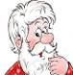









JIM
ANNA
LIZ
SARAH
JOHN
MARK
SALLY
Match the words to the pictures for Sarah. Write the number in the box.
1. brother 2. father 3. mother
4. aunt 5. uncle 6. cousin 7. grandmother
8. grandfather

PHIL
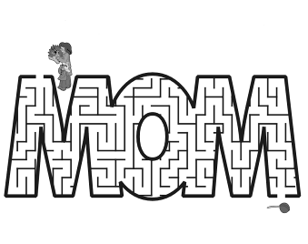
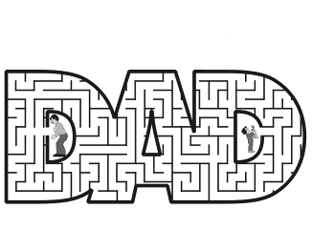
DAD is short for ____________________
MOM is short for ____________________
Help the father find his son.
Help the mother find the baby’s rattle.
Q R S S F R Z P R K Q A V T V H N F I D F N
K E E O N A P E L O I H F U N Z F A C H T C
Y X R H X E T M O T H E R K F U O B L J T P
R T E Q T S Z H R K X X C A T F A C H B V R
N W H J I A P R E H T O M D N A R G C L L X
L U T S W H F M J R D I S X F K P I O B W P
O A O K Y P O D Y D L Z Q P F P S U U O W F
S B R Z D F V G N Y A Z N F G T B P S I F U
Z R B C R D G Q S A E L C N U M B T I V U D
M X E R K X C H O O R B W N Y G G R N T K O
V G B L C B Z T X T A G N G Z V A L Q E C W
M M Z B U K A X L U X N G Y A S H B B J W Y

SARAH’S
FAMILY
Look at the family tree and write the answers.
1. Anna is Sarah’s ____________________
2. Susie is Sarah’s ____________________
3. John is Sally’s ____________________
4. Mark is Sarah’s ____________________
5. Liz is Sarah’s ____________________
6. Sally is Sarah’s ____________________
7. John is Susie’s ____________________
8. John is Susie’s ____________________
9. Jim is Sarah’s ____________________
10. Sarah is Mark’s ____________________

Circle the family words and write them.

1. _________________
2. _________________
3. _________________
4. _________________
5. _________________
6. _________________
7. _________________
8. _________________
9. _________________

AUNT BROTHER COUSIN FAMILY FATHER
GRANDFATHER GRANDMOTHER MOTHER SISTER UNCLE

SUSIE
cousingrandfatherfathersistermothergrandmotherauntbrotheruncle

