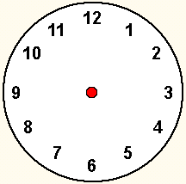  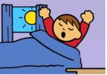  I get up  at ______________. | 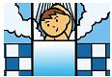  I have a shower  at ______________. | 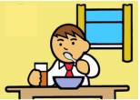  I have breakfast  at ______________.
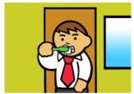  I brush my teeth  at ______________. | 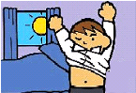  I put on my clothes  at ______________. | 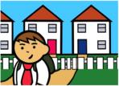  I go to school  at ______________.
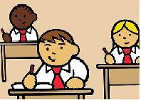  School starts  at ______________. | 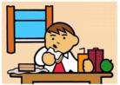  I have lunch  at_______________. | 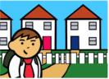  I finish school and go home  at _______________.
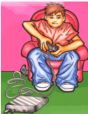  I play computer games  from ____________  to______________. | 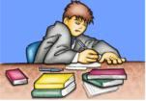  I do my homework  from_____________  to________________. | 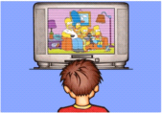  I watch TV  from _____________  to _______________.
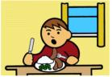  I have dinner  at______________. | I have a shower  at _______________ | 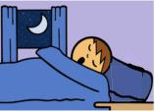  I go to bed  at _______________.

Illustrated by Ian Flynn

