
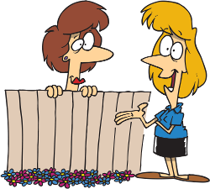









_______________
_________________
_________
_____________
1
10
9
8
7
6
5
11

Complete with the words in the box.
_____________
How are you ?
Nice to meet you.
How do you do ?
______________
_____________
____________
______________
Would you like one ?
____________8
_________
4
3
2
Goodbye. How do you do? Hi. Good morning. Sorry.
Yes, please. Good night. Fine, thank you. Nice to meet you, too.
You’re welcome. Thank you.

